**Exercise 9: Online Bookstore – Understanding HATEOAS**

Business Scenario:

Enhance your REST API to follow HATEOAS principles for navigation through resources.

Hypermedia as the engine of application state (HATEOAS) is a constraint of the REST software architectural style that distinguishes it from other network architectural styles. With HATEOAS, a client interacts with a network application whose application servers provide information dynamically through hypermedia.

1. **Add Links to Resources:**

* I used **Spring HATEOAS** to add links to resources in my API responses initially by adding dependency in pom.xml file:

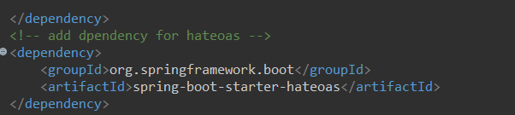

1. **Hypermedia-Driven APIs:**

* I built and consumed hypermedia-driven APIs:

BookController.java:

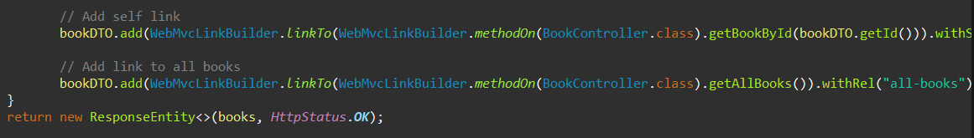

**Output:**

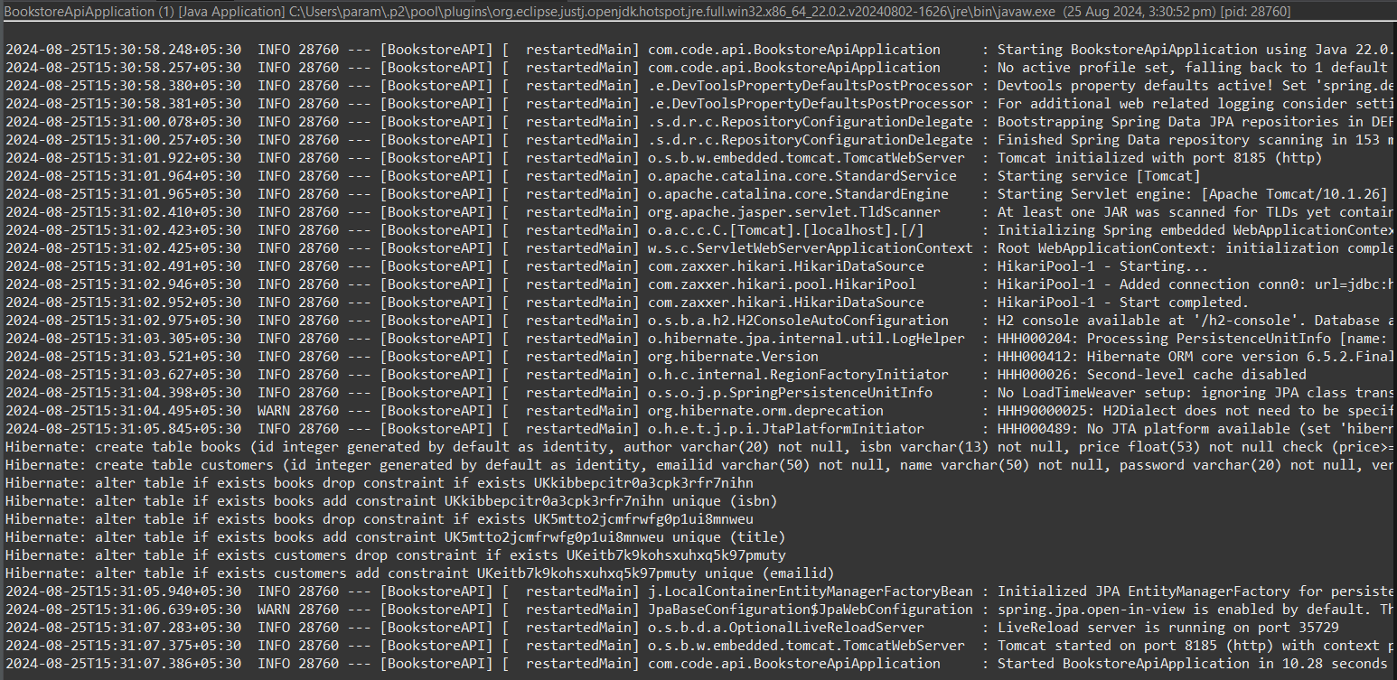

Add a book using POST and implement GET then the links get displayed:

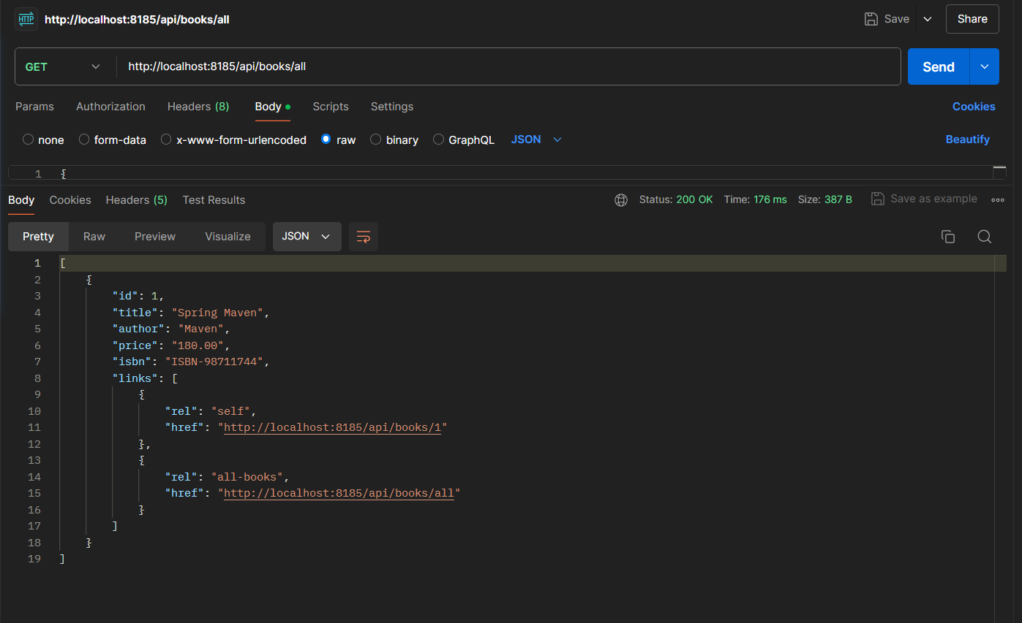

Clicking on first link:

